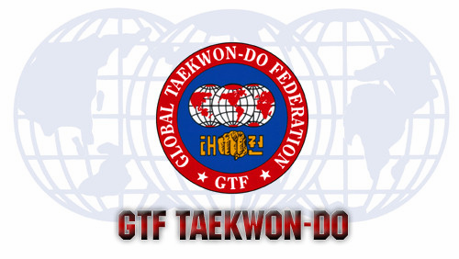

OUR FIRST EVENT FOR 2020!
GTF Training Seminar
PATTERNS SPARRING SELF DEFENCE

White-Black Belt, ages 6+ Morning only: 9 am-noon
Lunch Break: 12-1 pm
Black Belt training continues 1 pm-4:30 pm

$15 Colour Belts, $20 Black Belts
Sat Jan 18th Brunskill School
101 Wiggins Ave N, Saskatoon SK

Hosted by: GLOBAL TAEKWON-DO MARTIAL ARTS
6th Degree Black Belt Instructors
Mr. C Mackintosh and Mrs. F Giesbrecht
All current GTMA members are welcome to attend

