DEAR INSTRUCTORS/PARENTS/STUDENTS:
Global TaeKwon-Do Martial Arts would like to extend an invitation to you and your students to attend the GTF Training Seminar on Sat Jan 18th, 2020.

The morning session from 9 am- noon is open for all belt levels from White through Black Belt and is for ages 6 and up. It will consist of fundamental techniques, kicking drills, and sparring. Students should bring sparring gear if they have it.
We will have a lunch break from 12-1 pm.
Training for Black Belts will continue in the afternoon from 1 pm - 4:30 pm.
At the afternoon session we will have time to go through the Black Belt patterns for each Dan level and cover the higher-level Step Sparring: 1 Step Free and Model.
This training seminar is a great opportunity for students, Instructors and Assistant Instructors of all levels to get a head start on their training for the new year and is especially beneficial to students preparing for upcoming testing and tournaments.

Registration fees are very reasonable, we are just covering the cost of the facility rental, and is
$15 for Colour Belts and $20 for Black Belts.

Location: Brunskill School, 101 Wiggins Ave N, Saskatoon.

Date: Sat Jan 18th,2020

Time: White-Black Belt, ages 6+ Morning only: 9 am-noon
Lunch Break: 12-1 pm
Black Belts only: 1 pm-4:30 pm

Registration forms and payment can be handed in to your Instructor or brought to the event.
Please contact Mr. Mackintosh or Mrs. Giesbrecht if you have any questions.
Thank you.

Name: ______________________________________ Age___________ Belt_______________

Name: ______________________________________ Age___________ Belt_______________

Name: ______________________________________ Age___________ Belt_______________

Address:_______________________________________________________________________
Telephone #_____________________________________ Email: ________________________
Instructor____________________________________________

Agreement: I, ________________________________________________________ hereby submit my application for registration in the 2020 Jan 18th Training Seminar
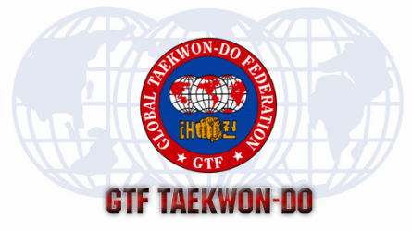
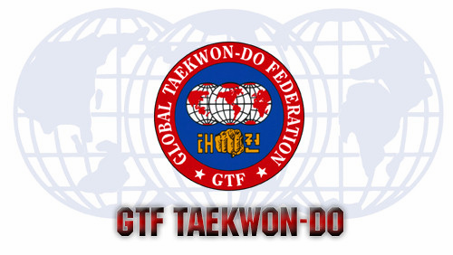
AGREEMENT: LIABILITY WAIVER: PLEASE READ AND SIGN. ALL MINORS MUST HAVE A GUARDIAN SIGN FOR THEM. THE PARTICIPANT AGREES TO COMPLY WITH THE RULES AND REGULATIONS OF THE SEMINAR AND ACKNOWLEDGES THAT PARTICIPATION IN THE SEMINAR IS PHYSICAL AND IN SOME CASES MAY RESULT IN INJURY TO THE PARTICIPANT. THE PARTICIPANT HEREBY WAIVES ANY CLAIM FOR DAMAGES OR INJURY AGAINST THE SEMINAR, INSTRUCTORS, GLOBAL TAEKWON-DO FEDERATION, GTMA, OR ANY OF THEIR AGENTS, EMPLOYEES, OR ANY INDIVIDUAL CONNECTED WITH THE ORGANIZATION. THE PARTICIPANT WILL ASSUME ALL RESPONSIBILITY IN THE EVENT OF INJURY BY ACCIDENT OR NEGLECT. ADDITIONALLY, THE PARTICIPANT ACKNOWLEDGES THAT HE/SHE IS FULLY AWARE OF HIS/HER PERSONAL MEDICIAL CONDITION AND HEREBY CERTIFIES THAT HE/SHE IS MENTALLY, EMOTIONALLY, AND PHYCICALLY FIT TO PARTICIPATE IN THE SEMINAR. LASTLY, THE PARTICIPANT HEREBY WAIVES ANY COMPENSATION WHATSOEVER FOR USE OF PICTURES, VIDEOTAPES, MEDIA COVERAGE, STATEMENTS, INTERVEIWS, ETC, UTILIZED BY THOSE PRODUCING OR DIRECTING THE SEMINAR AT ANY TIME. SEMINAR OFFICIALS HAVE THE RIGHT TO REFUSE ANYONE FROM ENTERING AND/OR PARTICIPATING IN THE SEMINAR AT THEIR DISCRETION.

APPLICANT’S SIGNATURE: _____________________________________________________
PARENT’S SIGNATURE________________________________________________________
Please make cheques payable to Hanulson TKD

